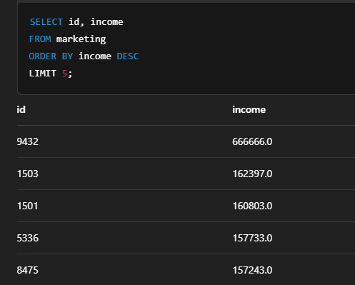

**Average Wine Spend by Marital Status**

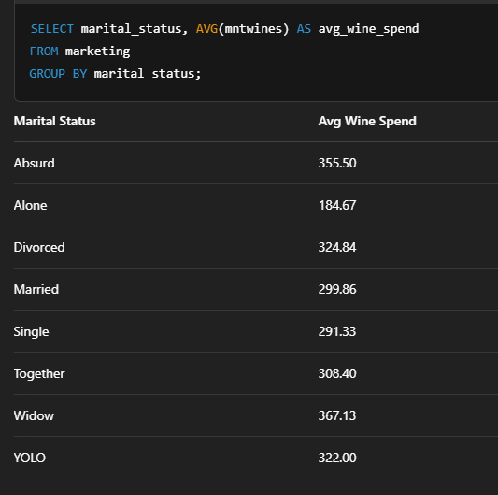

**Total Spending by Education Level**

SELECT education,

SUM(mntwines + mntfruits + mntmeatproducts + mntfishproducts +

mntsweetproducts + mntgoldprods) AS total_spent

FROM marketing

GROUP BY education

ORDER BY total_spent DESC;



**Customer Count by Year of Joining**

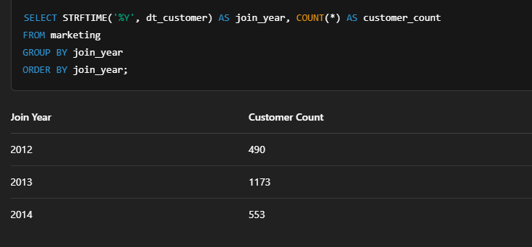

**Number of Accepted Offers by Campaign**

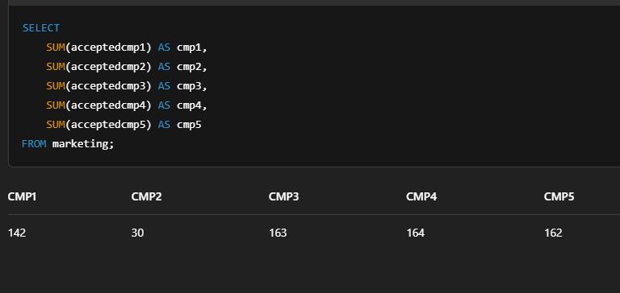

Execute all queries and collect results

results = {

"Top 5 highest-income customers": pd.read_sql(query_1, conn),

"Average wine spend by marital status": pd.read_sql(query_2, conn),

"Total spending by education level": pd.read_sql(query_3, conn),

"Customer count by year of joining": pd.read_sql(query_4, conn),

"Accepted offers by campaign": pd.read_sql(query_5, conn),

}

OUTPUT:-



. Number of accepted offers by campaign

query_5 = """

SELECT

SUM(acceptedcmp1) AS cmp1,

SUM(acceptedcmp2) AS cmp2,

SUM(acceptedcmp3) AS cmp3,

SUM(acceptedcmp4) AS cmp4,

SUM(acceptedcmp5) AS cmp5

FROM marketing;

